CHAPTER 4: Chemical patterns
Worksheet 4.8

Covalent bonding
Student: Class:

Models of molecules
1. The following diagrams show some common covalently bonded molecules.
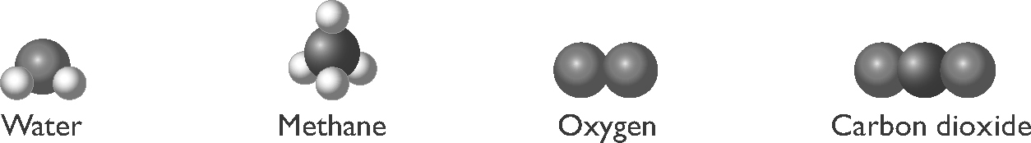
Electron dot diagrams can be used to show the arrangement of electrons in covalent molecules. Carbon dioxide is shown for you.
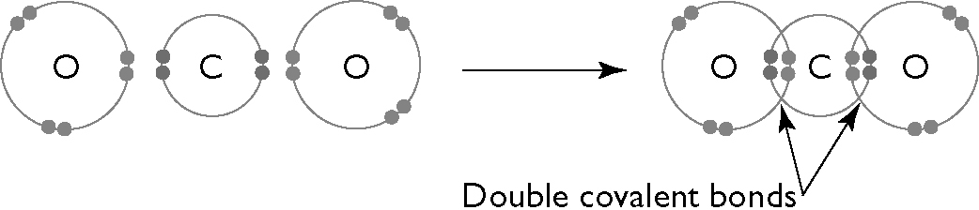
Draw electron dot diagrams for water, methane and oxygen.
Water | Methane | Oxygen

Lightning
2. In a lightning storm the molecules of oxygen and nitrogen in the air can react together to form nitrogen monoxide molecules. The word equation for this reaction is:
nitrogen gas + oxygen gas → nitrogen monoxide gas
(a) How many atoms are present in:
(i) a nitrogen molecule (ii) an oxygen molecule?
(b) Using the following key, draw models of the reactant and product molecules in the above word equation to create a balanced equation.

